Geometry: Unit 6, Lesson 9
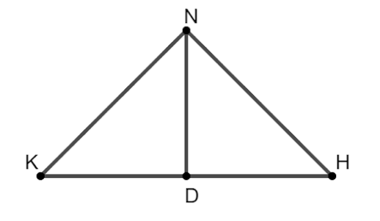
- Triangle $KND$ and $DHN$ are shown. Using the image, what reason justifies the statement $\overline{ND}≅\overline{ND}$?

Reflexive property of congruence

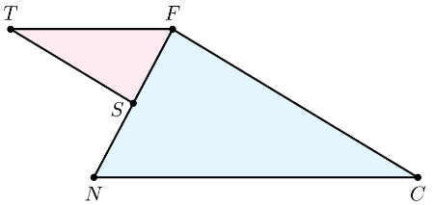
- Triangles $FST$ and $FCN$ are shown. $∠TFS≅∠CNF$ and $\frac{FS}{NF}=\frac{FT}{NC}$. What angle is approximately equal to $∠T$?

$$∠C$$

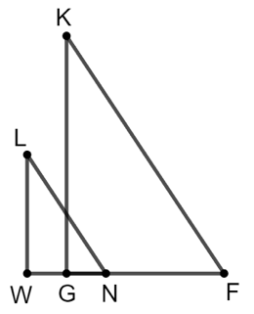
- Triangles $LNW$ and $GFK$ are shown. $\overline{LW}∥\overline{KG}$ and $\overline{LN}∥\overline{KF}$. $∠LNW≅∠GFK$ because when two parallel lines are intersected by a traversal, then what are congruent?

Corresponding angles

